



**EE464 STATIC POWER CONVERSION II**

**Final Report**

Team Members: Ozan Aktürk 2303923, Ekin Arda Çömez 2374791, Ahmet Bilgin 2231488

Deadline: 28/06/2023 23:59

Lecturer: Assoc. Prof. Ozan Keysan

Assistant: Ogün Altun

## Introduction

The isolated DC-DC converter design for the specifications indicated below requires several design and testing steps. Firstly, the topology had to be selected depending on the ratings and group member preferences. After that, the main power stage of the converter had to be designed followed by the controller selection and implementation into the circuit. The components were selected with the considerations explained below. The physical implementation came with several problems. The tests were made, and the demonstration has been conducted. This report explains all these steps and what we learned from this project.

## Topology Selection Considerations

The topology selection was explained in detail in “Simulation and Magnetic Design Report”. This report includes the summary of why we chose Flyback topology for the project.

* The general expectancy of the efficiency of the flyback converter is applicable to this project [1].
* Most of the other groups were choosing the flyback topology, meaning that a supportive network could be created.
* Flyback topology was also the most selected topology by the previous year’s groups. They could also be good references (mostly for the magnetic design) for the project.
* The components were mostly available on the laboratory or quite cheap. Note that comparison with other topologies was not made.
* The component number is relatively small which will be mentioned again in the controller design section.

Regarding the reasons mentioned above, the flyback topology was selected for this project.

## Magnetic Design Considerations and Tests

Next, the transformer had to be designed. The necessary values for the flyback converter were selected/calculated as follows (the MATLAB file which includes all the calculations is included in the GitHub repo):

* N2/N1 = 3
* Minimum magnetizing inductance (primary referred) = 59.68 uH
* The maximum current = 8.318 A (without losses)
* N1 = 16 (five parallel of AWG21), N2 = 48 (two parallel of AWG21)
* B = 0.1205 T

The core selection was made considering the laboratory inventory. The cores available at the lab were investigated by reading each of their datasheets. The sizes, saturation limits, inductance per turn squared values, and window sizes were compared. The selected core was 00K4022E090 with its coil former.

The physical implementation of the transformer brought several challenges. First of all, the coils had to be stranded. The drill was used to strand to coils. Next, although the fill factor (around 0.3) stated otherwise, winding the coils were not possible with the selected values above. We needed to decrease the turn numbers to N1 = 10 and N2 = 30 to be able to wind the paralleled coils. After the turn number changes, the transformer was winded very strictly and the coils had nearly no empty space between them. The inductances were measured with the LCR meter available in the lab. The measurements are included in the following figures.

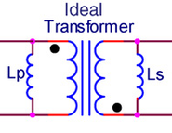

1. **Ideal transformer representation.**

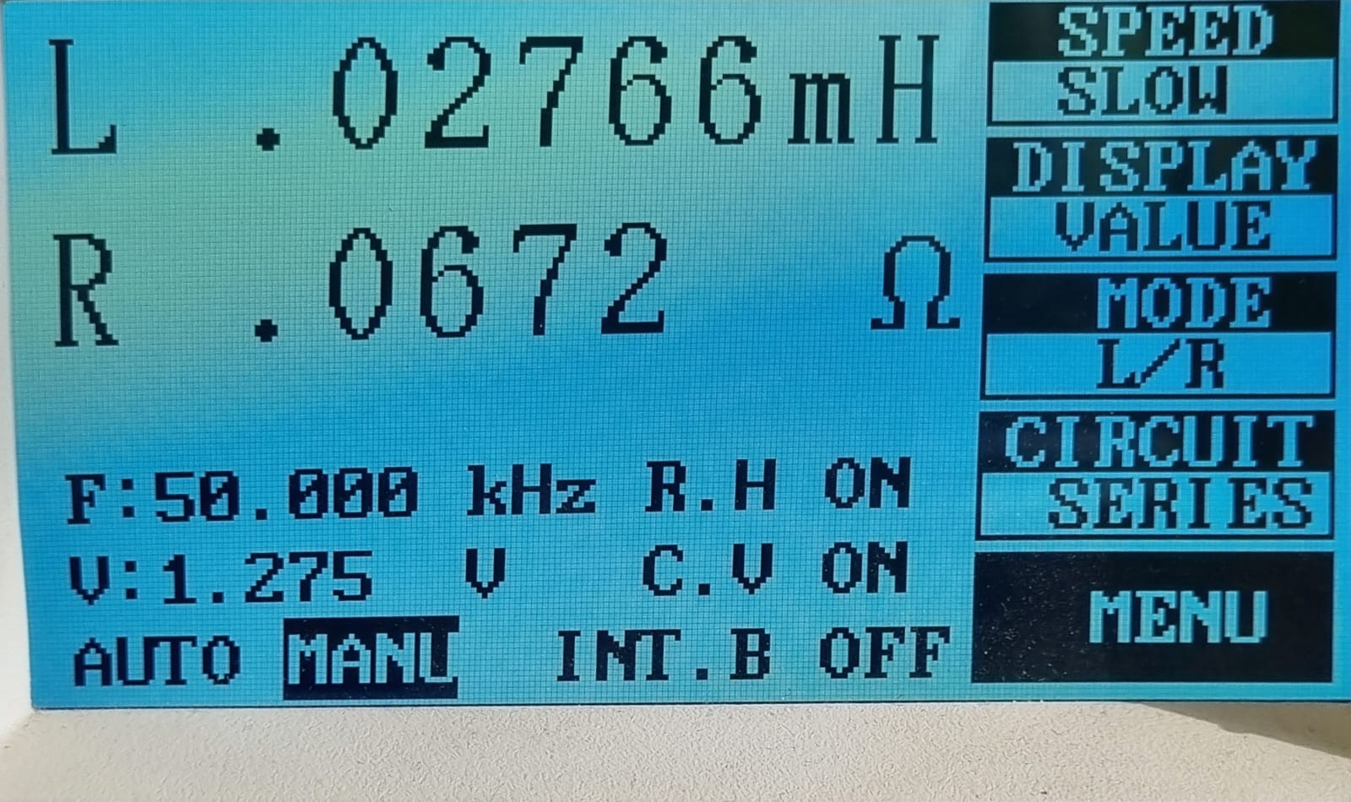

1. **Secondary side open circuited, primary side measurement.**

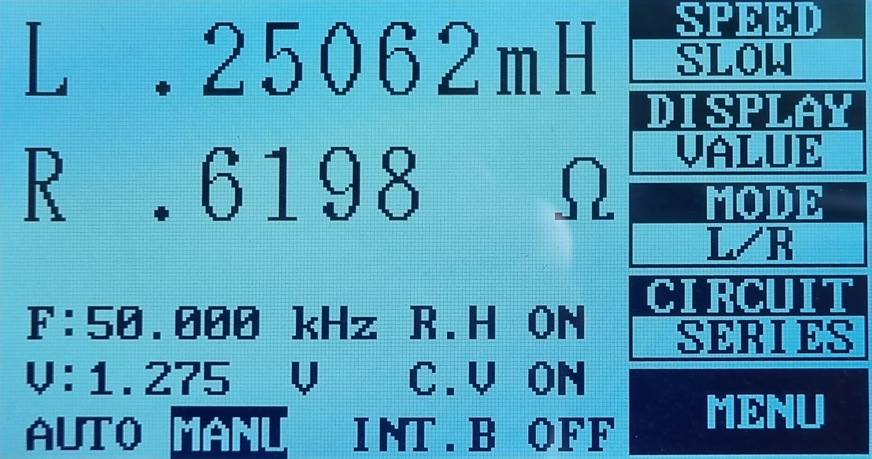

1. **Primary side open circuited, secondary side measurement.**

From Fig. 2 and Fig. 3, the turn ratio is calculated as N2/N1 = Sqrt(0.25062 / 0.02766) = 3.01, which is what we wanted.

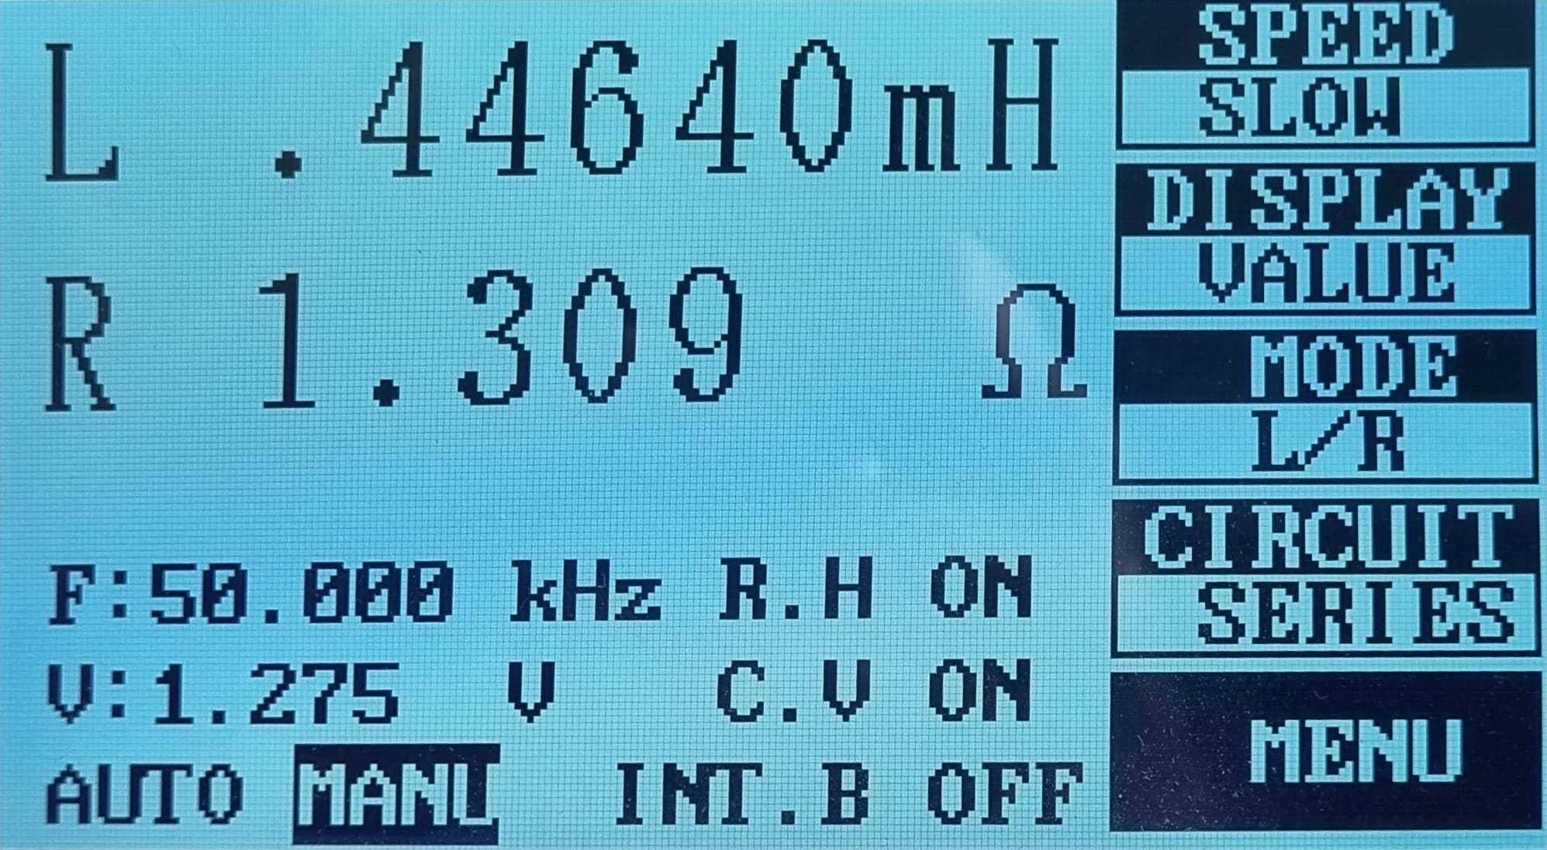

1. **Two dotted or two undotted terminals are shorted, measurement taken from the other available terminals (Lp + Ls + 2M).**

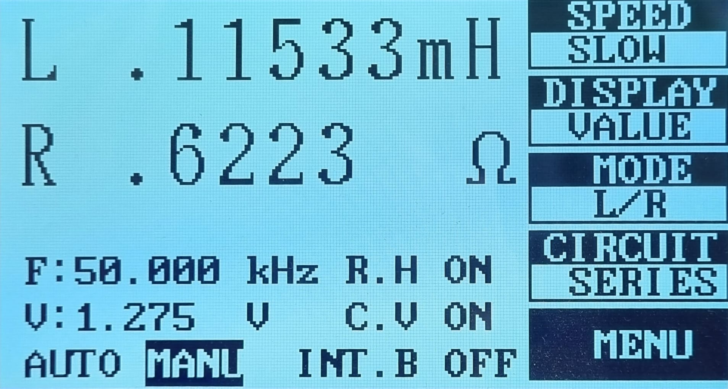

1. **One dotted and one undotted different side terminals are shorted, measurement taken from the other available terminals (Lp + Ls - 2M).**

The magnetizing inductance is calculated from Fig. 4 and Fig. 5 using the logic in Fig. 1 as:

Lm = (0.44640-0.11533)/4 = 82.77 uH, which is larger than what is calculated for the design. However, the result does not harm any other quantity such as B_max of the core or I_max. It only changes the CCM-DCM boundary which will be compensated by the controller. Also, the core losses are expected to be decreased as the current ripple is further reduced meaning that the used region in the B-H curve is reduced.

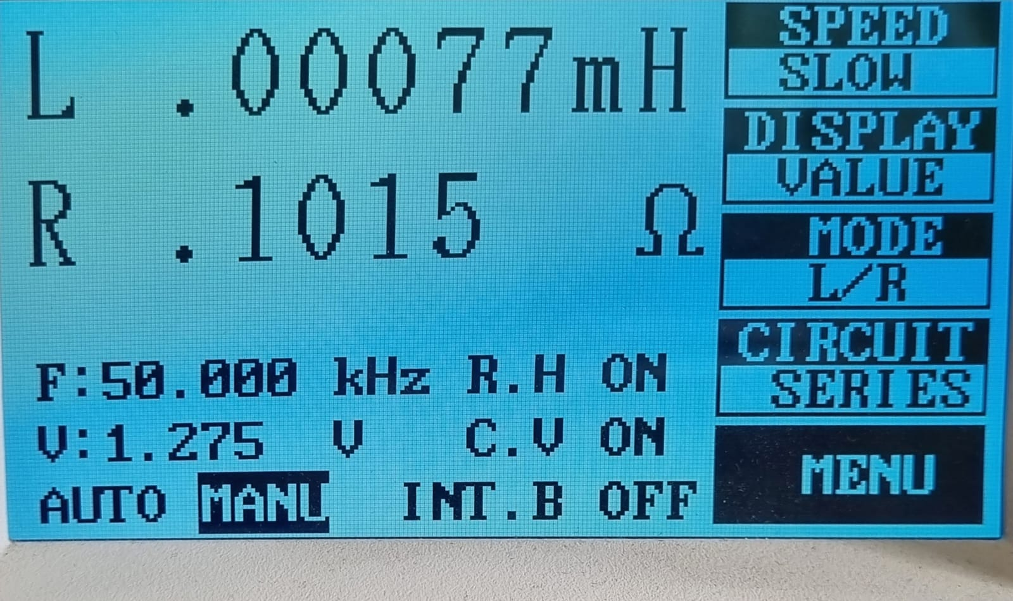

1. **Secondary side short circuited, primary side measurement (leakage inductance referred to primary).**

Since the winding part of the implementation was quite difficult by itself, we didn’t wind the primary and secondary side windings in a changing manner order to decrease the proximity effect as the leakage came out to be 77/2766 = 2.7%, which less than 5%.

Next, to see if the transformer worked as desired (1:3 ratio) and determine the polarity of the terminals, a signal generator is connected to the primary side of the transformer and oscilloscope measurements are taken from both sides. The expected behavior was to get 90 degrees phase shifted waveforms and voltage ratios to be around 3 which is shown in Fig. 7.

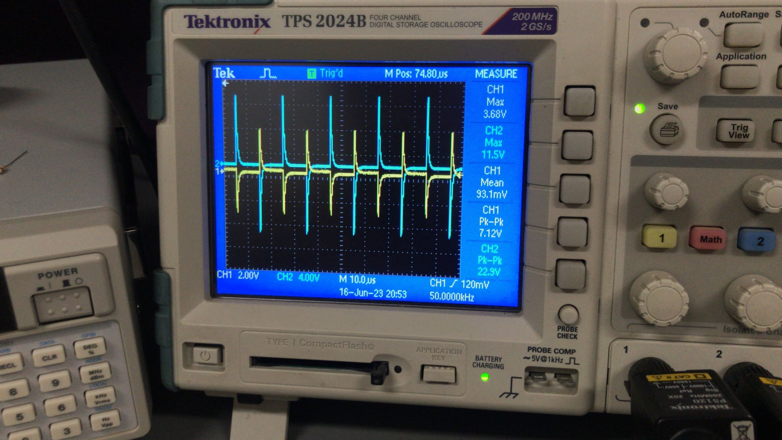

1. **Transformer test. CH1 is primary and CH2 is secondary.**

Here, the ratio came up to be around N2/N1=3.13 unlike LCR meter findings. We though that one of the measurement devices was used wrongly. In any case, this result is unimportant as the controller will compensate for the discrepancies related with the transformer.

## Controller Design

-TI design figure & explanation (github)

## Computer Simulations

-Ltspice simulation results (input & output voltage, input & output current for different loads and input voltages, MOSFET and output diode voltages & currents, other important waveforms)

-Comments after each figure

## Component Selection

## Test Results

Photos with figure names (yukarıdakilerden kopyala yapıştırınca figür numarası nereden kaldıysa devam ediyor)

## Conclusion

## References

[1] [Improving the Performance of Traditional Flyback-Topology With Two-Switch –Approach](https://www.ti.com/lit/an/snva716/snva716.pdf)